**Accuracy** is one of measure for the prediction of models, the more the accuracy the more good is the performance of model.

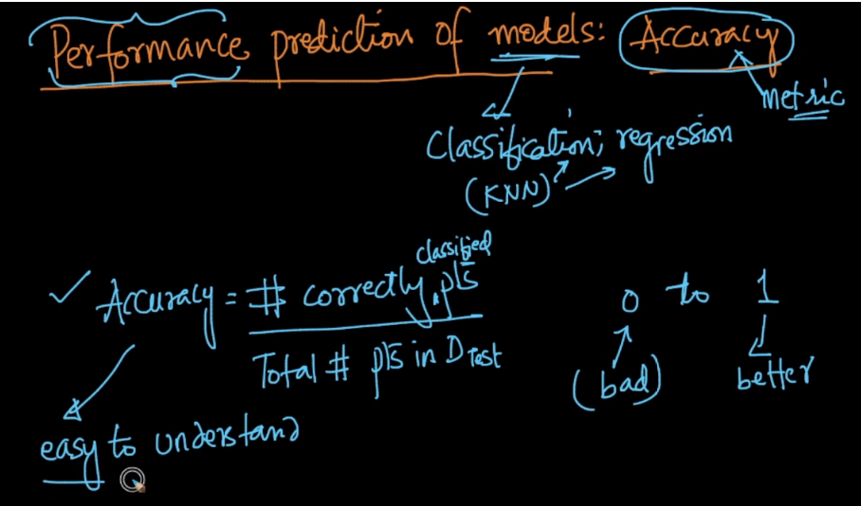

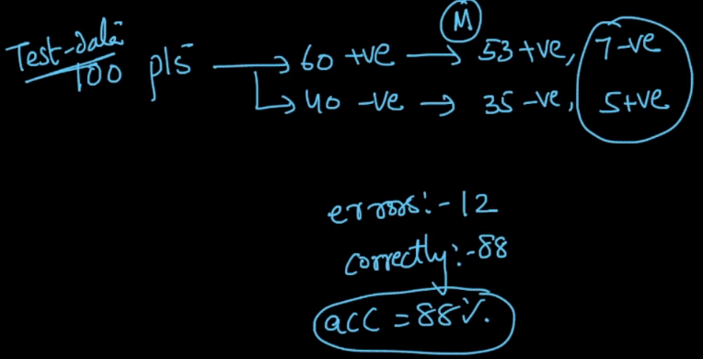

Pto

But accuracy can’t be measured in some places, let’s understand them.

**1) Imbalanced Data:**

In case of Imbalanced datasets, Accuracy is not a right performance metric to be used

Let’s say we have test data in which 90% of points are -ve and 10% are positive,

And we have a dumb model which always predict output as -ve, The model is said to be dumb in the case of Underfitting(where it mostly gives same value as an output)

So For this also we get accuracy of 90% which is very high.

Therefore we must check whether data is balanced or not before measuring performance of a model.

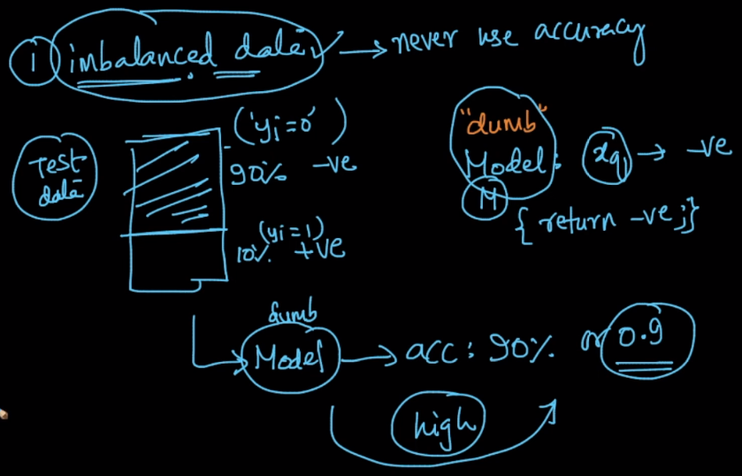

**2) Model which generates probability score:**

Since accuracy is only computed using the value it generates as output and it not consider the probability of generating that output. Therefore we would not be able to make decision of which model is better given two model based on accuracy.

Let’s take an example, where we have two models M1 and M2 which generates output as probability of getting 1 as output.

We have dataset with output for each datapoint.

Now seeing below table we can say that model M1 is much better than M2 as it is clearly disitinguishing between classes. But to get accuracy what we do, we predict it’s value which is also attached in below table for both the models.

As we can see just by seeing output as class label both models are giving same accuracy even though M1 is far better than M2, and we won’t be able to identify the best model among them.

